Proposed Total Right Knee Replacement Procedure Drawing

<https://www.google.is/search?q=drawing+of+a+new+knee&biw=1920&bih=955&tbm=isch&imgil=38q9ChMyd9sHKM%253A%253BFDeNx1whYOOkMM%253Bhttp%25253A%25252F%25252Ffiguredrawingonline.com%25252Fblog%25252Ftag%25252Fknee%25252F&source=iu&pf=m&fir=38q9ChMyd9sHKM%253A%252CFDeNx1whYOOkMM%252C_&usg=__A61sOLaFTR8Dp7o7OcW1vP6pA10%3D#imgrc=nInjOpcMbLGFDM%253A%3BmYh1IoOGcJ8esM%3Bhttp%253A%252F%252Fjbjs.org%252Fcontent%252F85%252F6%252F1018%252FF9.large.jpg%3Bhttp%253A%252F%252Fjbjs.org%252Fcontent%252F85%252F6%252F1018%3B1280%3B888>

000

**Alternatives to Knee Replacement Surgery**

<http://www.healthline.com/health/total-knee-replacement-surgery/alternatives#3> **--- klikka á þessa slóð til að skoða allt Alternatives to Knee Replacement Surgery**

**Knee replacement is a major surgery, and should only be performed when absolutely necessary.**

[http://ad.doubleclick.net/N4788/ad/hn.us.hl.lc.x.x.x;sz=597x38;tile=30;pos=ip;ord=8631239149075849?](http://ad.doubleclick.net/N4788/jump/hn.us.hl.lc.x.x.x;sz=597x38;tile=30;pos=ip;ord=8631239149075849?)

Weight Loss and Exercise

Working with a Physical Therapist

Knee Injections (Hyaluronic Acid)

Medication or Cortisone Shots

Acupuncture

Prolotherapy

Arthroscopic Surgery

**Stem Cells**

This experimental treatment **uses bone marrow stem cells from the hip** to help regenerate cartilage tissue in the knee. **A small but growing number of doctors are turning to cutting-edge stem cell therapy as an alterative to knee replacement surgery**. **One** [**study**](http://jbjs.org/content/96/2/90) **found that stem cell therapy after knee surgery helped reduce pain and repair the knee.**

Knee Osteotomy

**Weigh Your Options**

**It’s important to consider all your options and explore alternatives to knee replacement surgery. However, discuss the procedure with your doctor if you’ve exhausted your options or your surgeon feels that your knee requires a total or partial replacement. Delaying a necessary surgery can cause additional long-term problems.**

˅

˅

˅

˅

˅

˅

˅

˅

˅ ( <http://www.healthline.com/health-slideshow/total-knee-replacement-surgery-step-by-step#2> )

˅

˅

˅

˅

˅

˅

˅

˅

˅

˅

v

**Hægra slóð** [**http://www.doereport.com/enlargeexhibit.php?ID=920**](http://www.doereport.com/enlargeexhibit.php?ID=920)



**Vinstra slóð** [**http://www.nucleuscatalog.com/total-knee-replacement/view-item?ItemID=10128**](http://www.nucleuscatalog.com/total-knee-replacement/view-item?ItemID=10128)

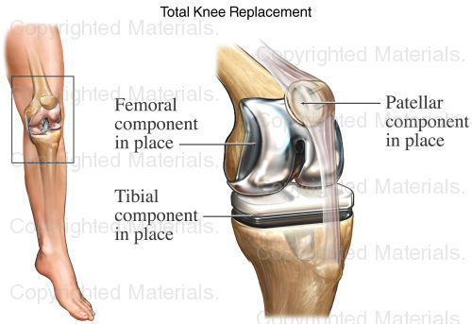

Hægra slóð <http://www.doereport.com/generateexhibit.php?ID=37001>

